Quantum Teleportation at a Glance

Frank Rioux

Emeritus Professor of Chemistry

College of St. Benedict and St. John’s University

The purpose of this tutorial is to provide a brief mathematical outline of the basic elements of quantum teleportation, as illustrated in the figure below, using matrix and tensor algebra.

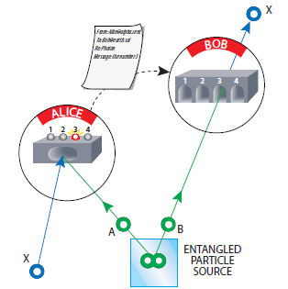

Alice wishes to teleport the following state (X in the figure) to Bob,



where



They prepare the following entangled two-particle state, involving A and B, in which Alice has particle A and Bob has B.



Alice arranges for the particle to be teleported, |Φ >, and her entangled particle to meet simultaneously on opposite sides of a beam splitter, creating the following the three-particle state.



It is not difficult to show that this state can be written as a superposition of the following 4-vectors, which are the well-known Bell states. Please see the Appendix for a definition of the Bell states.



We now write this three-particle state in terms of the Bell basis labels.



Next, Alice makes a Bell state measurement on her two particles, getting any of the four possible outcomes (Φ+, Φ-, Ψ+, or Ψ-) with equal probability, 25%. Her measurement collapses the state of Bob’s particle into the companion of the result of her Bell state measurement. Alice then sends the result of her measurement through a classical channel to Bob. Depending on her report, he carries out one of the following operations on his particle to complete the teleportation process.





The following three-wire quantum computer circuit simulates this teleportation protocol. The first step is to create the appropriate Bell state on the bottom two wires using the Bell state index |00> (see the Appendix). This is followed by a Bell state measurement by Alice on the top two wires. Alice’s Bell state measurement in this case yields Ψ- with index |11>. This measurement result activates the controlled-NOT and controlled-Z gates yielding the teleportee state on the bottom wire, as shown in the last equation on the right above.



This circuit is implemented using the Quirk quantum simulator.



**Appendix**

The Bell basis is the following collection of maximally entangled two-qubit states. The indices for the Bell states are |00>, |01>, |10> and |11>, respectively.







